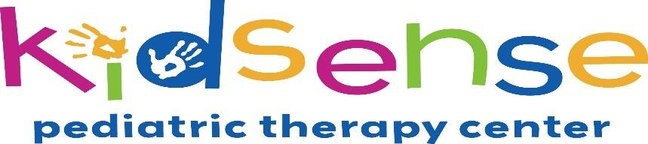

&

Hood River
Cinemas

presents a SENSORY-FRIENDLY movie

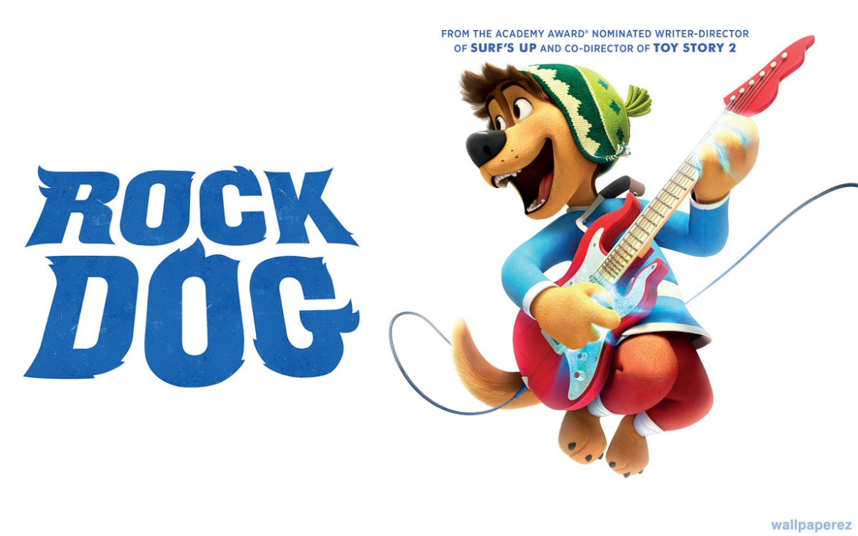
Lights turned up, so not too dark • Sound turned down, so not too loud
All ages welcome!
G and PG rated movies
Saturday, March 11th, 2017
9:30am
$5.00
Hood River Cinemas
Call Kidsense with Questions: 541-386-0009

